SOKOINE UNIVERSITY OF AGRICULTURE

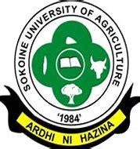

DEPARTMENT OF SOIL AND GEOLOGICAL SCIENCES (DSGS)

MSc RESEARCH PROGRESS PRESENTATIONS

RESEARCH TITLE: Growth and Yield of Grain Legumes in Response to Sulphur Fertility Management

STUDENT NAMNE: Martin Moshi
SUPERVISORS: Dr. Nyambilila A. Amuri, and
Prof. Raymond R. Weil

VENUE: DSGS MSC. LECTURE ROOM
DATE: 24th JAN 2025
TIME: 10:00 AM

YOU ARE WARMLY WELCOME!

